PEACE AND ORDER

1. CCTV

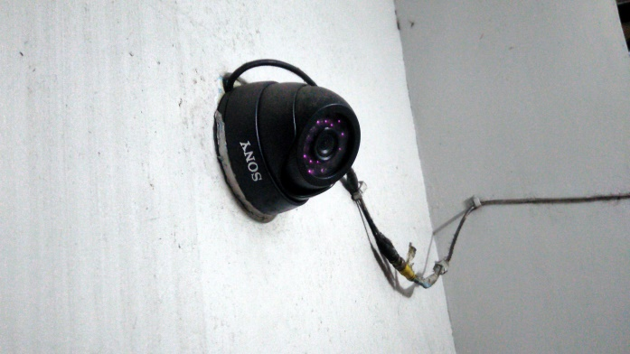

Closed-circuit television is installed had been one of the best evidence for crimes that had been committed.

1. Traffic
2. Jeepney passengers
3. Police